# Make your first Web Page in a Text Editor (Notepad)

1. Go to the Start Menu > All Programs > Accessories > Notepad
2. In the empty Notepad file type ( or paste) the following:

***Please Note: If you are new to Web design it is best to type the following in – as this helps make you aware of the different elements…***

1. The Most Basic Webpage in the World. It is an intro to HTML!

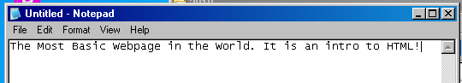

1. Now you will add the HTML tag to identify that this is a Webpage.
2. Type <html> before all the text.( use lower case)
3. Type </html> after all the text.

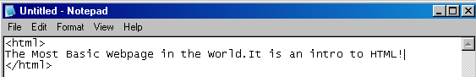

1. We will now add the HEAD tag – Web browsers will display a page without it – but it is considered ‘proper’ to include them. The head contains information about a Webpage – such as the Title – the text does not appear on the actual Webpage
2. Type < head> directly below the HTML tag.
3. Press ‘Enter ‘twice and type the closing </head>

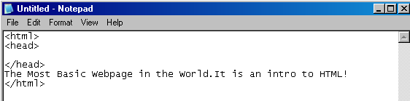

1. You should give the Webpage a title that describes its contents – it will appear in title bar of a Web Browser – it helps visitors know where they are and also assists when bookmarking a site – you can see what you have bookmarked!
2. Type <title> directly below the <HEAD> tag. Type the title of the Webpage, using only letters and numbers then close the </title> tag
3. <title>My First Webpage</title>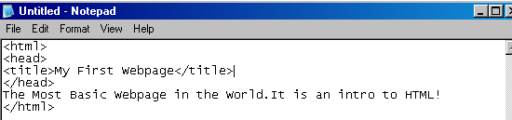
4. You must have the <BODY> tags around ANY content you want the viewer to see on your Webpage. Add the opening and closing <body></body> tags to the content – type below the <HEAD tag> and before the end of the page above the <HTML> tag

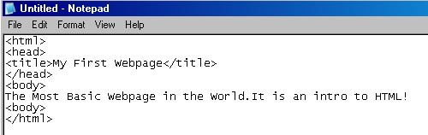

1. Choose File > Save As
2. In the Save As box go to your folder on your home drive. You can create a new folder if you like called Week 1, open it.
3. In the File name **type firstwebpage.html** ( do not use capitals or spaces)
4. The Save As Type should be Text Documents{*txt} and Encoding ANSI   
   Click Save

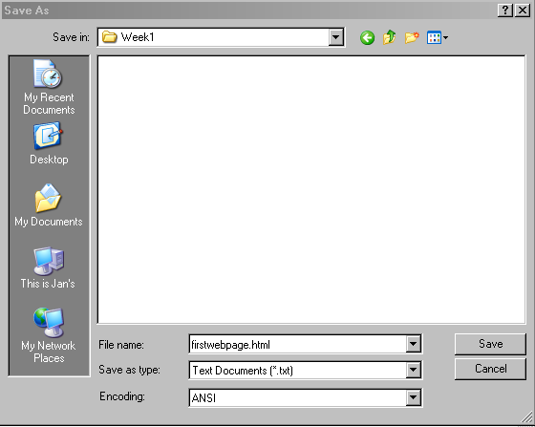

# Display Your Webpage in a Browser

You can display your webpage in any browser as a preview of how it will appear on the Web.  
Keep in mind though – this is only a preview and it is not available for other people to view – you will have to upload the page to a Web server on the Internet for other people to view.

You are making a Webpage ‘locally’ – that is - on your computer. When it is uploaded to a Server it will be called ‘remote’

1. Start the Web browser you want to use. In this case I used Internet Explorer.
2. To open in the Web browser go to File> Open

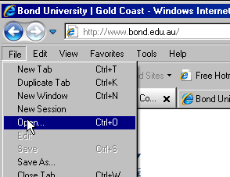

1. In the Open box Click Browse and navigate to your previously saved Webpage

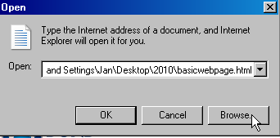 Click OK

1. You are now able to see what your webpage would look like if it was uploaded / published to the Web! Check the elements – Title and Body

Title

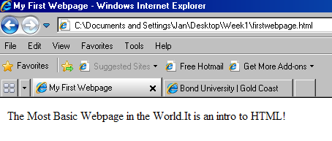 Content (body) of the Webpage

However as everything is on one line – I want to add a paragraph break. Web browsers usually ignore line breaks that you type.

1. Go back and open the saved file - as it is now an HTML file you will need to Right Click the mouse and choose > Open With > Notepad

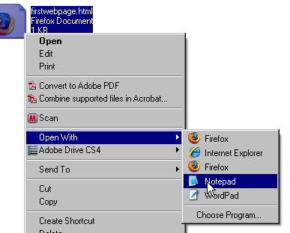

1. You are going to separate the sentence into two lines (with a paragraph break)
2. After the word 'World' and before the word 'It' in the sentence type the paragraph tag <p>
3. At the end of the sentence type the closing tag </p>
4. Save your file and preview your changes in Internet Explorer.

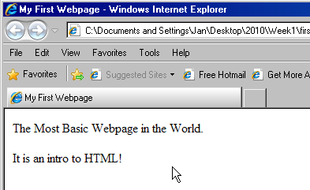

1. In the page display of Internet Explorer > Right Click > Choose View Source to see your code.
2. Now - Try viewing the Source code of other websites.

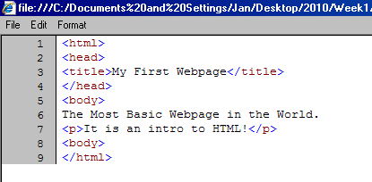  
Well Done! – This is an introduction to HTML to take the fear factor away for those new to Web design! You have now started on the Web Design pathway.